Supermarket Sales Dataset and Data Analysis

1. Introduction
The proliferation of data in the modern business world has made data analysis an indispensable skill. This project demonstrates the capabilities of Microsoft Excel as a robust, accessible, and essential tool for performing advanced data analysis and creating compelling visualizations. Using a real-world Supermarket Sales Dataset, this analysis aims to transform raw transactional data into actionable business intelligence, showcasing Excel's features like PivotTables, advanced formulas, and scenario analysis.
2. Aim and Objectives
The primary aim is to conduct a thorough data analysis of supermarket sales to identify key trends, performance metrics, and profitability drivers.
Key Objectives:
- Data Preparation: Clean, transform, and prepare the raw sales data for analysis.
- Performance Measurement: Calculate and analyse key performance indicators (KPIs) like total sales, profit margin, and customer count.
* Visualization: Create interactive and insightful dashboards and visualizations (e.g., Pivot Charts) to communicate findings effectively.
* Strategic Insights: Derive actionable insights and provide data-driven recommendations to improve supermarket performance.
3. Business Problem/Context
In a competitive retail environment, supermarkets face the challenge of optimizing inventory, maximizing profitability, and enhancing customer satisfaction. Without proper analysis, management often makes decisions based on intuition rather than data.
The core business problem this project addresses is:
* Identifying the Profit-Driving Segments: product Line, customer Type, regions, or Date contribute most significantly to the supermarket's overall profit.
* Addressing Underperformance: Where are the potential areas of loss or low performance that require immediate action.
4. Project Workflow
This outlines the step-by-step process of the analysis.
* Data Acquisition: Obtain and load the Supermarket Sales Dataset into Excel.
* Data Understanding & Cleaning: Profile the data and address quality issues.
* Data Transformation: Create new columns for derived metrics (e.g., Profit Margin).
* Exploratory Data Analysis (EDA): Use PivotTables and basic charts to explore initial patterns.
* Advanced Analysis: Apply statistical formulas, filtering, and segmentation.
* Visualization & Dashboarding: Design comprehensive and interactive charts and dashboards.
* Scenarios & Insights: Perform 'What-If' analysis and extract actionable business insights.
* Conclusion & Recommendation: Summarize findings and propose strategic actions.
5. Data Understanding
* Dataset Source: Kaggle Supermarket Sales Dataset.
* Data Overview: 5054 rows/ 9 columns (Date, Branch, Gender, Product line, Customer type, Unit price, Quantity, Payment, Rating).

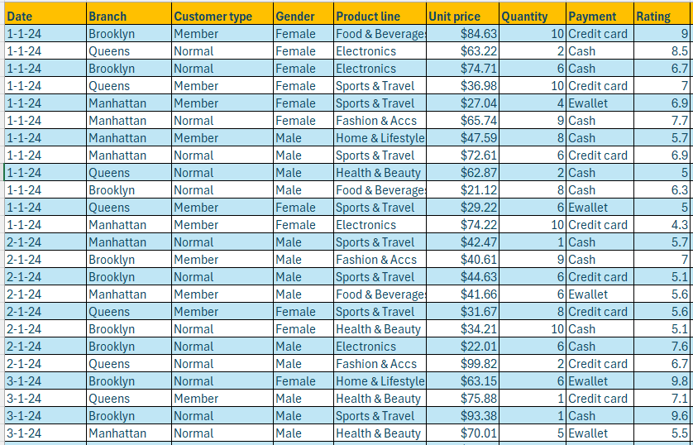

6. Data Cleaning and Preparation
This stage ensures data quality for reliable analysis.
* Data Type Correction: Numerical columns are in Number/Currency format.
* Removing Duplicates: Removed Duplicates. (None found).
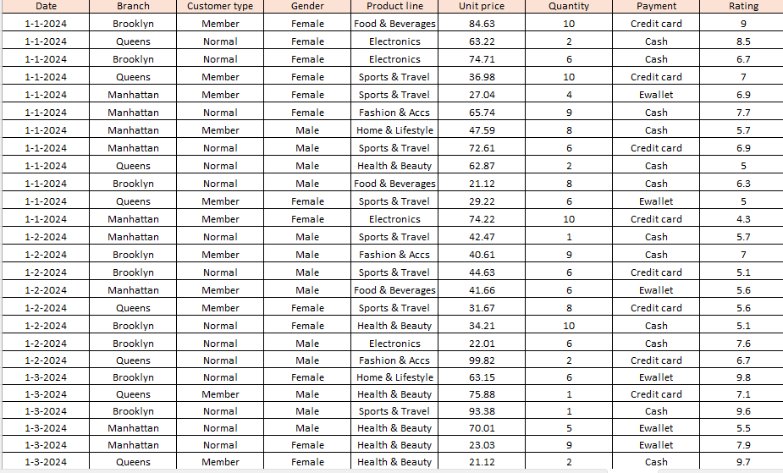
RAW DATA
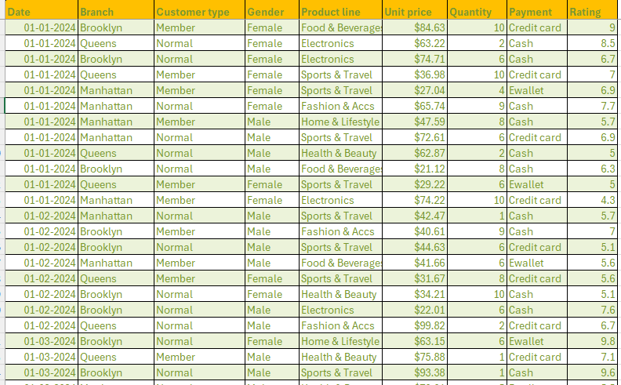
CLEAN DATA
7. Derived Metrics (New Columns)
These metrics are essential for profitability analysis and are created using Excel formulas.
- Total Revenue: sum (unit price* Quantity).
- Average Revenue: Average ()-mean sales value per unit.
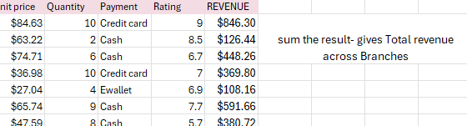

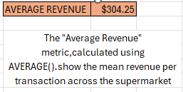

8. Filtering and Segmentation
- Filtering helps select specific row of data based on conditions like date, branch, gender.
- Segmentation groups data into categories to compare unit price and Quantity.
9. Statistics and Formulas
Applying core statistical functions in Excel to summarize and analyse the data.
* Summary Statistics: Use functions like AVERAGE- Average ()-mean sales value per unit.
* Conditional Logic: Use IF statements to create a new Rating Categories(ifI1>=9,” Excellent”, if(I1>=7,” Good”, “Average”)).
* Lookup Functions: Use XLOOKUP Fetch Gender/ Customer type for a branch. (=XLOOKUP (B757, B2:B9, C2:E9).

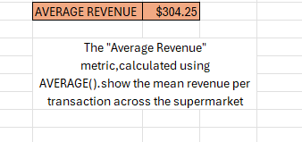
Mean sales value per unit.

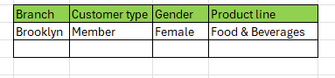
Fetch Gender/ Customer type for a branch.

Rating segmentation:
- Excellent: Rating 9-10
- Good: Rating 7-8
- Average: Rating <6
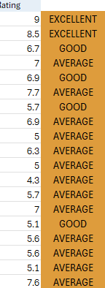
10. Exploratory Data Analysis (EDA) and Visualization
EDA is performed primarily using PivotTables and their associated Pivot Charts.
PivotTable & PivotChart
- Rating split by Date-see how satisfaction moves over time.
- Average Rating by customer type and gender- spot which segment is happiest.
- Unit price by Branch and payment method-check where revenue and payment mix differ.
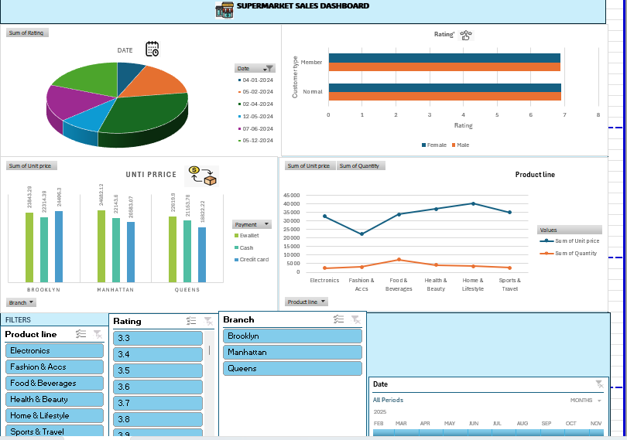

11. Scenario Analysis (What-If Analysis)
Scenario Manager:
Goal: Evaluate how changing unit price affects Total revenue.
Goal Seek:
Achieving target sales (Average. Target Adjustment).

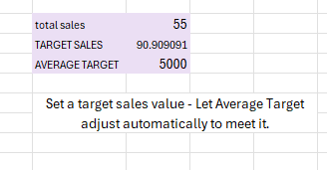

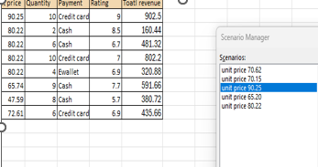

12. Insights and Conclusion & Recommendation
INSIGHT:
- Members buy more items than normal customers.
- Food and health and beauty are the top selling product line.
- Higher rating come from customer who buy more quantity.

RECOMMENDATION:
- Offer more promotions for top-selling product lines.
- Improve stock and service in lower-performing branches.

CONCLUSION:
The supermarket sales analysis shows which customer, product and branches perform better.by studying the data, we found useful patterns that can help improve sales and customer satisfaction. The results can guide the supermarket to make better decision and plan effective strategies.

BY:
Aarthi. P,
Data Analytic Batch 2025.

